Converter MPC-210 (Code 702.042)

Technical passport

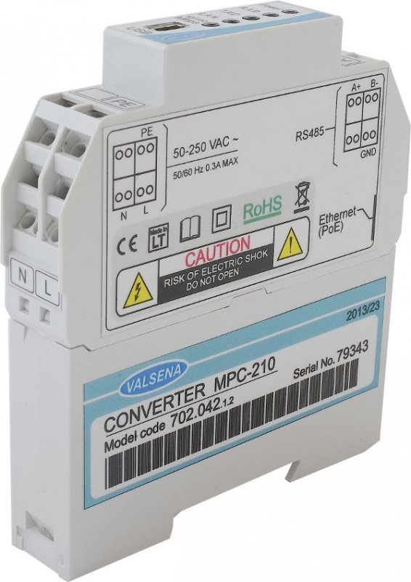

Kaunas
© 2013

Device purpose
- Data exchange between RS232/RS485/I²C and Ethernet;

Device delivery set
- Converter MPC-210 1pc.
- Technical passport 1 pc.
- Software 1 pc.

Technical data

Overall specification
CPU: ARM Cortex M3
Memory: archive storage 1-8 MB, battery backup, valid up to 5 years.

Interfaces
RS232: up to 15m, speed up to 19,2 Kbits/s
RS485: up to 1.2 km, max 32 transceivers, speed up to 19.2 Kbits/s
Ethernet: 10/100 Mb twisted pair, up to 100m
USB: mini-B USB ver. 2.0

LED indication
Power
Serial port read/write for each port
Ethernet status

Protocols
Modbus RTU, Modbus TCP/IP, IP, ICMP, UDP, TCP, DHCP, PPP, ARP, SNTP

General
Power supply AC: 50-250V ~ 50/60Hz
Power supply DC: 50-400V
Power over Ethernet: PoE (IEEE 802.3af) - see manufacturer's code
Power consumption : <300mA
Interface galvanic isolation: 1000V
Real time clock: Yes

Physical characteristics
Dimensions: 18x85x97 mm
Weight: 105 g
Case fixing type: DIN35
Protection type: IP20

Climate conditions
Operating temperature: -25 .. +60ºC
Storage temperature: -40 .. +60ºC
Humidity range: 5 – 95%, non- condensing

Programing and updating
Remotely: Ethernet
Locally: USB

Model code
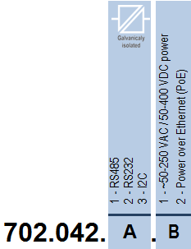

Model code explanation

702.042.A.B

A- First socket (UART1)
1 | RS485
2 | RS232
3 | I²C

B- Power
1 | 50-250VAC/50-400VDC
2 | PoE (Power over Ethernet)

Manufacturer warranty
Warranty period – 24 months.
In case of controller’s unavailability, the manufacturer commits to replace or carry out repair free of charges, if device was used in accordance with the operating manual.
A guarantee does not apply to faults caused by force majeure.

Putting into operation certificate

Controller MPC-210

Model code: 702.042.2.1

Serial number: 85971

Date of manufacturing: February 2016
S.P.

Controller is correctly assembled and completed.
The person responsible for certification: Rūta Mockutė

